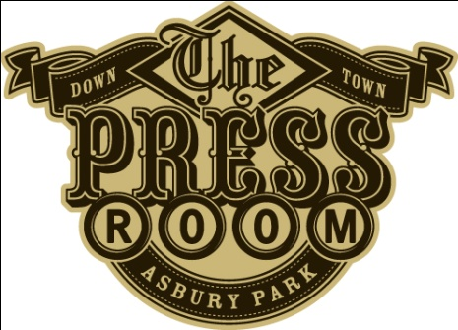

Specialty Gourmet Cupcakes

$ 4 – “The Press Room” - Chocolate and Coffee Flavored Cake with a Bailey's Irish Cream Frosting

$ 4 – “After Party” - Chocolate Cake topped with White Chocolate & Godiva Vodka Buttercream

$3 – “Road Trip” - Chocolate cupcake filled with Chocolate and Raspberry Ganache topped with Peanut Butter Frosting

$3 – “Red Carpet” - Red Velvet Cake topped with Cream Cheese Icing Sprinkled with Sugar

$3 – “Greetings from Asbury Park” - Cinnamon infused Yellow Cake with Cinnamon Cream Cheese Frosting

$3 – “Rock N' Roll” - Chocolate Cake stuffed and topped with Chocolate Fudge

Made by: Confections of a Rock$tar

