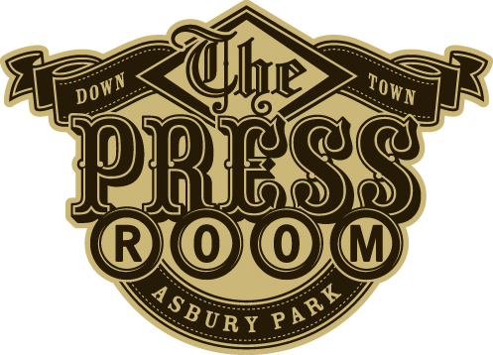

$7 - Turkey chili $8 with Jack cheese & sour cream
$7 - Hummus plate - served with toasted pita bread & pickled veggies

$ 7 - Bruschetta – tomatoes, roasted red peppers, artichoke hearts, capers

$8 - Spinach and carmelized onion dip served with toast points

$7 - Homemade Mac n Cheese with toasted rye bread crumbs

$10 - Ruben Mac n Cheese. Traditional mac n cheese with a hint of swiss. Layered with corned beef, sauerkraut, and topped with toasted rye bread crumbs

$7 Cold pasta salad w/veggies and jalapeno cream sauce w/garlic toast

$10 - Pear Salad – Mixed greens, pear, candied walnuts, bacon & blue cheese crumbles tossed in balsamic vinagrette
$8 - Grilled vegetable panini w/ goat cheese, zucchini, squash, peppers, onions and mushrooms w/ rosemary

$8 - BBQ Pulled Pork Sandwich

$8 – BLT (That’s it)

$11 - London Broil Sand. – Thin sliced seasoned London Broil with carmelized onions and garlic mayo pressed on garlic toast

Menu conceptualized by SHIAH BLAU

Chef/Owner COLONEL’S KISSING BOOTH 516 Summerfield Avenue A.P.

Executed by: Chris Pappas

